Examining New York State’s Contributions to the Civil War
Through the West Point Foundry.
This activity utilizes items from the Putnam History Museum’s collection to demonstrate the impact of the West Point Foundry’s Parrott rifled cannon on the Civil War. Students should read the introductory text before using the collection items and historic newspaper quotes to answer the questions on each page.
Extension Activity: Organize a class trip to Scenic Hudson’s West Point Foundry Preserve, where students can listen to a guided audio tour on the history of the Foundry.
https://www.scenichudson.org/explore-the-valley/scenic-hudson-parks/west-point-foundry-preserve/
NYS Learning Standards:
7.8c Students will examine the role of New York State in the Civil War, including its contributions to the war effort and the controversy over the draft.
11.3c Students will compare the relative strengths of the Union and the Confederacy in terms of industrial capacity, transportation facilities, and military leadership. And evaluate the reasons why the north prevailed over the South and the impacts of the war.
Teacher Overview:
During the Civil War, New York provided more war materials, money, and troops, than any other state in the Union. The Hudson River Valley served in part as a military industrial complex. Watervliet Arsenal (Watervliet), Burden Iron Works (Troy), Ulster Iron Works (Saugerties) and the West Point Foundry (Cold Spring) made everything from horseshoes to cannons to supply the army and navy. The United States in the North had the industrial infrastructure to win the battle of production.
West Point Foundry was one of many manufactories that contributed to the US victory in the Civil War. The Parrott rifled cannon and corresponding projectiles were the company’s main products during the war. The West Point Foundry’s use of industrial work practices helped the company produce approximately 3,000 pieces of artillery and 3 million rounds of ammunition during the conflict. Their workforce reached 1200 employees during the Civil War, allowing the Foundry to operate its furnaces 24 hours a day, seven days a week.
The Parrott cannon was patented by West Point Foundry superintendent Robert Parker Parrott in 1861. The gun’s rifling provided greater range and accuracy than other artillery pieces of the era. It was manufactured exclusively by the West Point Foundry. The gun was produced in seven calibers. The 10 and 20 pounders were used in the field, the 30, 100, 200, and 300 pounders were used in sieges, and the 60 pounder was produced for the Navy in 1864 (weight refers to projectile size). The Navy mostly armed its warships with 30, 60, 100 and 200 pounders. The Foundry’s Parrott cannons saw action at some of the Civil War’s most important battles, including: Bull Run, Gettysburg, Antietam, and the Siege of Charleston Harbor.
Student Introduction
The American Civil War began in 1861 and ended in 1865. The United States fought 11 Southern states that seceded from the Union to form the Confederate States of America. To secede means to leave a group or community. The Southern states supported slavery and did not believe the federal government had the right to outlaw slavery in American territories that were not yet states. Abraham Lincoln pledged to outlaw slavery in American territories. When he was elected president in 1860, seven southern states seceded and formed the Confederate States of America. On April 12, 1861, a Confederate army attacked Fort Sumter in Charleston, South Carolina. Lincoln ordered militia to stop the attack and four more slave states joined the Confederacy. This event was the first battle of the war.
New York State remained with the Union and played an important role in the war. Between 1815 and 1861, the North when through industrialization. Industrialization occurs when workers start to use machines in factories to do work that was once done by people. New York’s many industrial sites helped the state produced more war supplies, money, and troops, than any other state in the Union. Many of the industrial sites were located in the Hudson Valley, including the West Point Foundry in Cold Spring, New York. A Foundry is a factory that makes products out of melted metal.
In this activity you will learn how the West Point Foundry helped the Union army during the Civil War. Use the text, quotes, and pictures to answer the questions on each page.
Review Questions
- What does it mean to secede? Why did southern states secede from the United States?
- The West Point Foundry made products out of melted metal. List 2-3 metal products that would be used in a war.

The Parrott Cannon
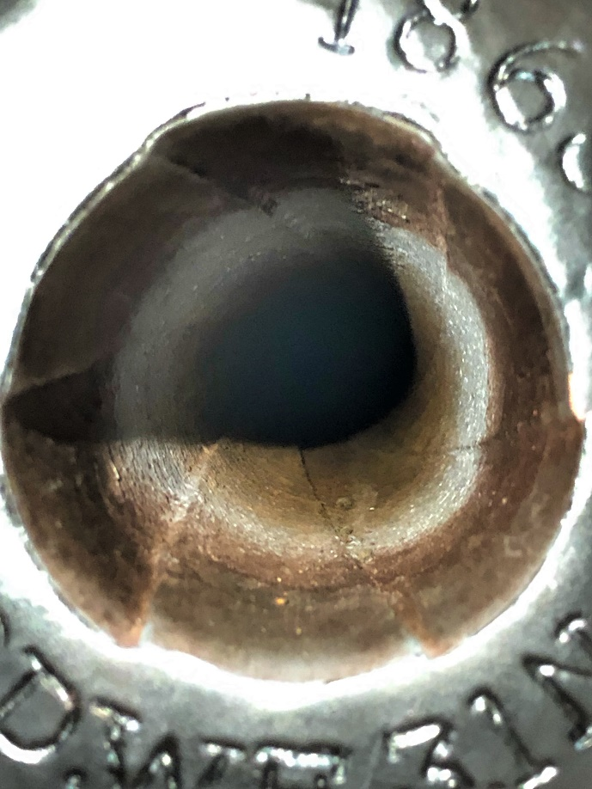
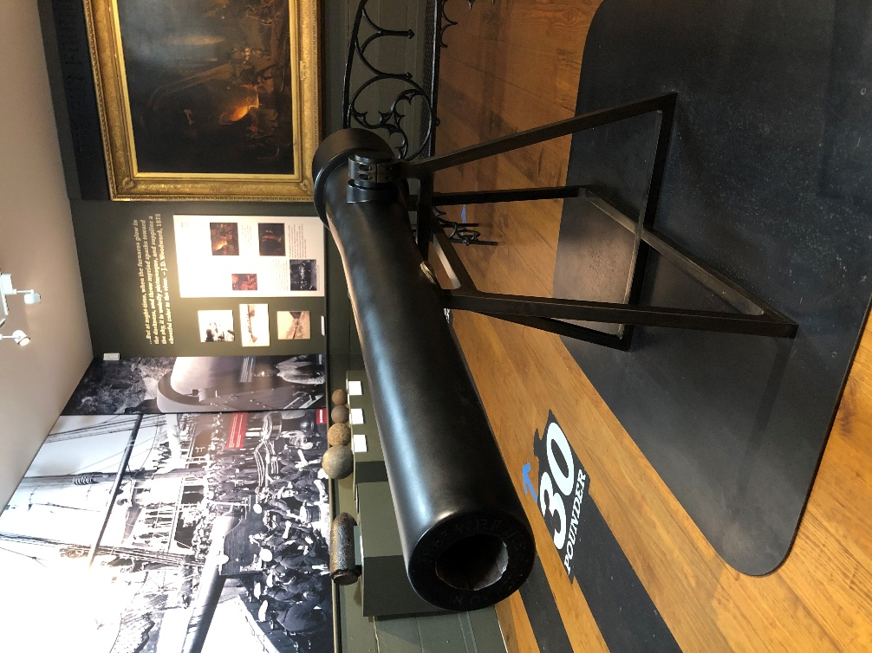

West Point Foundry superintendent Robert Parker Parrott patented the Parrott cannon in 1861. The inside of the cannon’s barrel was rifled. Rifling a cannon adds grooves to the barrel which make a projectile spin when it is fired. This spinning helps the shell fly straight and travel farther. The Parrott Cannon’s range and accuracy made it one of best cannons available during the Civil War. It was only made at the West Point Foundry, in Cold Spring, New York.
Primary Source Quote:
“In my opinion, there is not a single element of this war of more importance in regard to effect than the artillery, and particularly this kind of gun (Parrott cannon)”
– The New York Times September 17th, 1863
Review Question
- Why was the Parrott cannon considered one of the best cannons available during the Civil War?

Parrott Cannon Shells
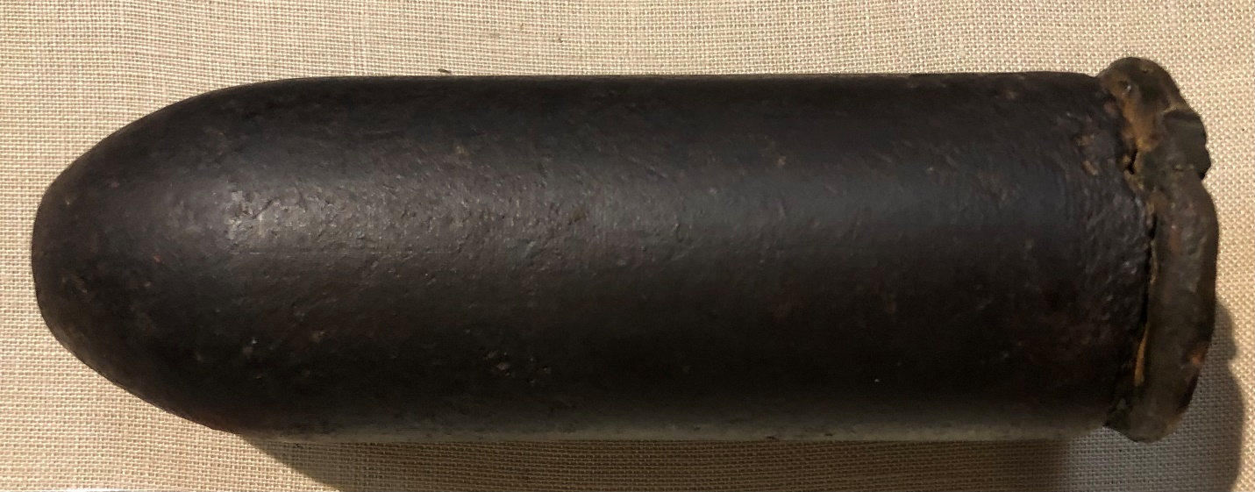

Parrott cannons were made in seven different sizes, each of them helped the Union Army in different ways. The bigger the cannon, the heavier its shells were. Cannons that fired 10 and 20 pound shells were used on the battlefield. The picture above shows a 10 pound shell. The 10 pound Parrott cannon was so heavy it required four horses to transport it. Cannons firing 30, 100, 200, and 300 pound shells were used to attack cities and forts during sieges. Finally, cannons firing 30, 60, 100 and 200 pound shells were used on Navy warships.
Review Question:
- Why do you think the West Point Foundry made the Parrott cannon in seven different sizes? Use the reading to support your answer.

Manufacturing the Parrott Cannon
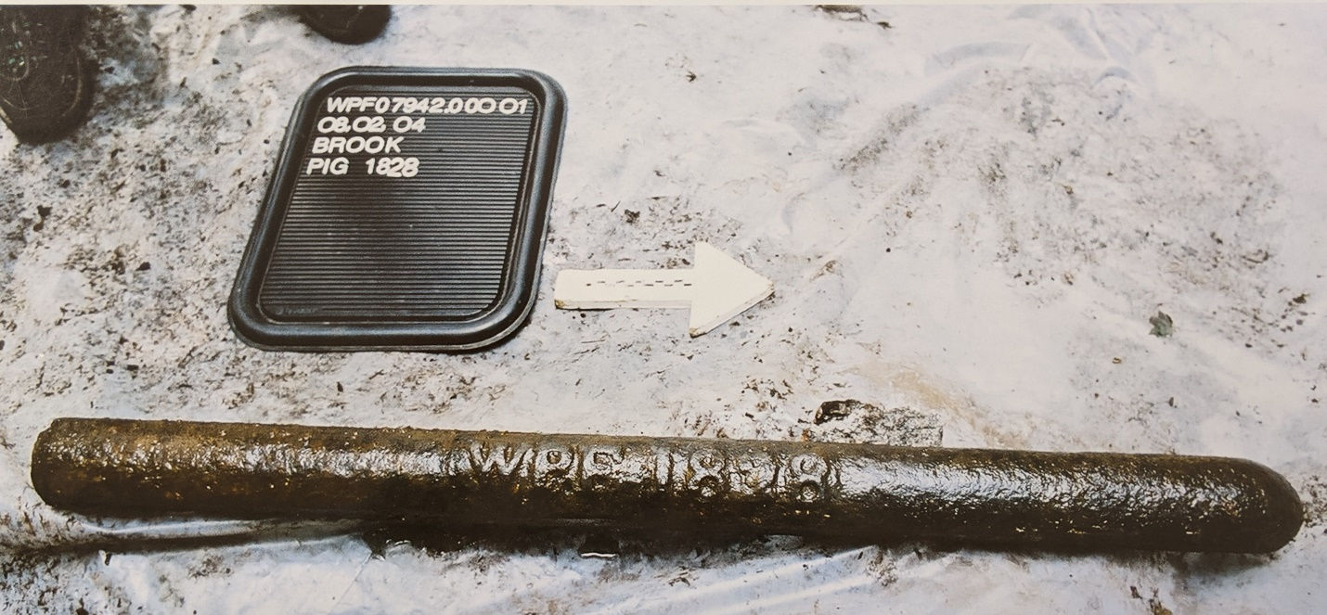

Natural resources are materials from the Earth that support human needs. The West Point Foundry used many different natural resources to build the Parrott cannon. Water from a stream propelled a water wheel that powered the Foundry’s machinery, and charcoal made from burned trees fueled furnaces where the iron was melted for Parrott cannons.
The iron bar in the picture above is called pig iron. Pig iron is a crude form of iron that can be melted into new products like cannons. During the Civil War, ships from Pennsylvania used canals to transport pig iron to the West Point Foundry.
When cannons were finished, they were transported to the Hudson River by train and then loaded onto ships that delivered the cannons to Governors Island Arsenal in New York Harbor. The North’s supply of natural resources and network of transportation routes helped the Foundry meet the Union Army’s need for cannons. Railroads helped transport cannons, men, horses, and supplies to battlefields. When the Civil War began in 1861, the North had about 21,000 miles of railroad tracks compared to the Confederacy’s 9,000 miles.
Review Questions
- Name two natural resources used to produce a Parrott cannon.

- How did the North’s transportation routes give them an advantage over the Confederates? Use at least 2 facts from the reading to support your answer.

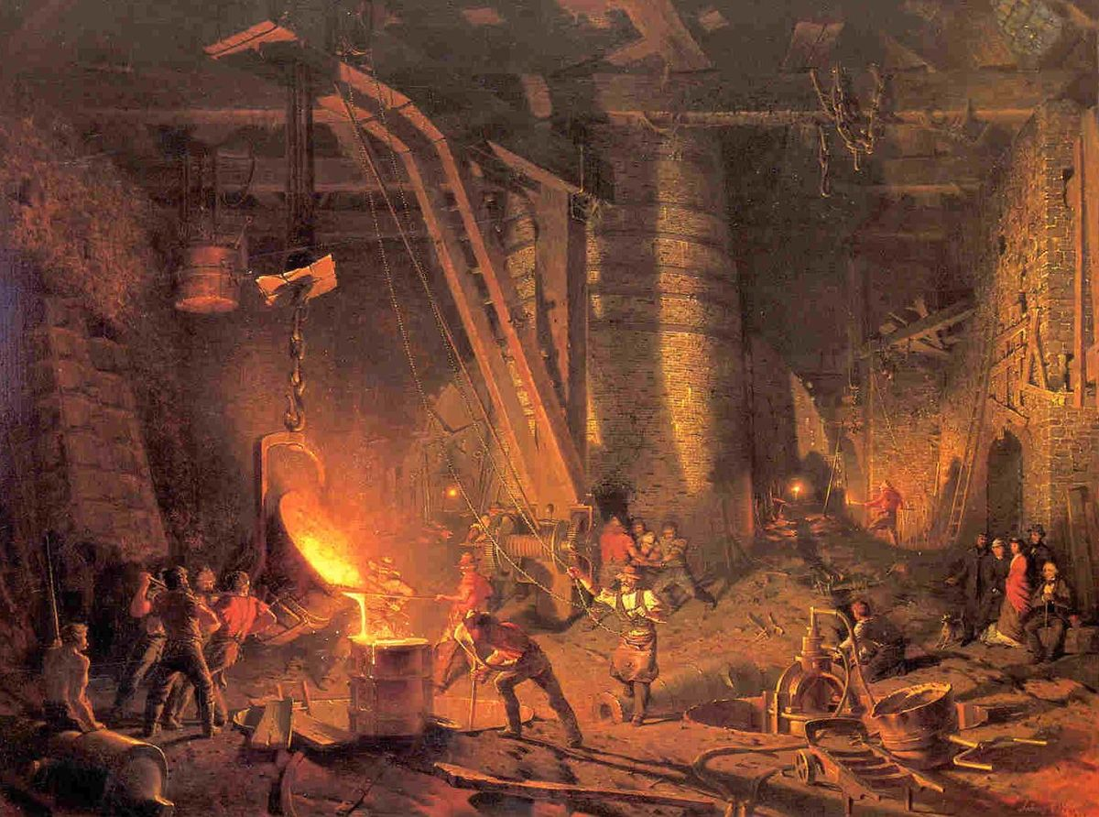
Manufacturing the Parrott Cannon

This painting is called The Gun Foundry, artist John Ferguson Weir painted it in 1866. It shows workers casting a Parrott cannon at the West Point Foundry. The Foundry employed 1,200 people during the Civil War and operated 24 hours a day, seven days a week. Each employee worked on a specific part of the cannon making process. By dividing the work between many people, the West Point Foundry produced cannons faster than traditional foundry shops.
Primary Source Quote
“During my visit I learned that since the war began over three thousand cannons have been manufactured here [The West Point Foundry] for our government -- the Parrott gun exclusively -- varying from those of the minimum calibre to 300-pounders. These guns have done duty in our forts, on our gunboats, and in our grandly-moving armies” – The New York Times July 2nd, 1865
Review Questions
- How would you describe the work being done by the men on the left of the painting? Who do you think the people on the right side of the painting might be?

- According to the newspaper quote, how many cannons did the West Point Foundry produce during the Civil War?

- How did the Foundry’s production process differ from traditional foundry shops?
The Parrott Cannon in Battle
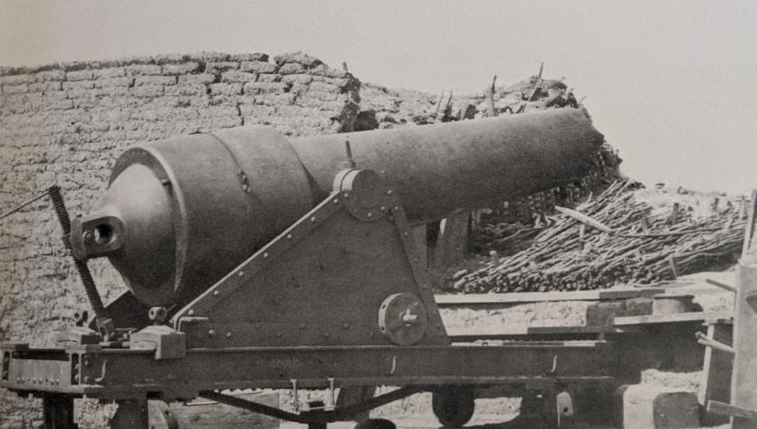
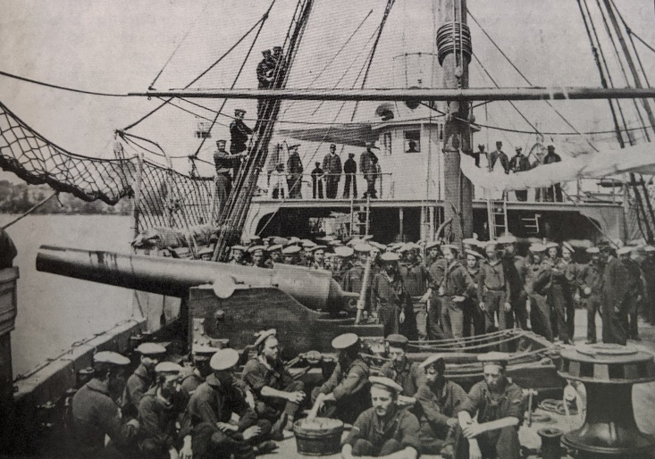
100 pound Parrott cannon on the USS Mendota. This gunboat helped prevent Confederate ships from trading with foreign countries.
A 300 pound Parrott cannon on Morris Island in South Carolina. This gun could fire a shell 4,200 yards. It helped the Union lay siege to Fort Sumter.

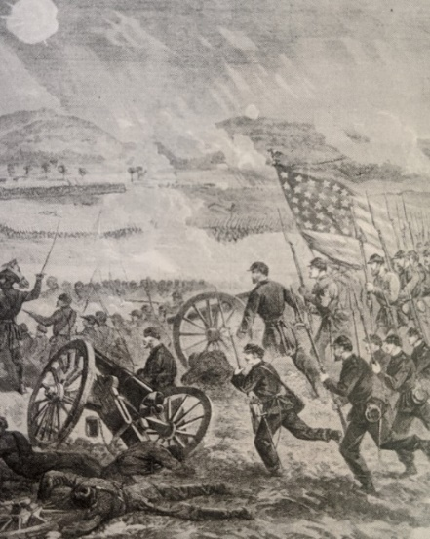
Sketch of 20 pound Parrott cannons at the Battle of Gettysburg. The cannon played a critical role at Gettysburg and other important Civil War battles like Bull Run and Antietam.

Review Question
Use the information you have learned in this activity to answer the following question in 3 - 4 complete sentences. Be sure to use at least 3 facts from the activity to support your answer
1. How did the West Point Foundry’s Parrott cannons help the Union during the Civil War?

