Name: ________________ Date: __________
Do Now: Use this map to answer the questions below.

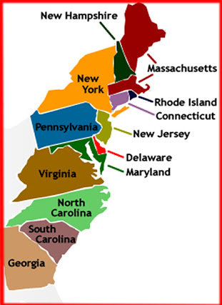

1. Draw a straight line from Pennsylvania to Massachusetts, what states do you cross through?
2. Now draw a straight line from Virginia to Connecticut, what states do you cross through?
3. Finally, draw a straight line from South Carolina to New Hampshire, what states do you cross through?

