Document Based Questions
Directions: Read each document carefully and then use them to answer the questions.

Document 1:
“The importance of the Hudson River in the present Contest, and the necessity of defending it, are Subjects which have been so frequently and fully discussed, and are so well understood, that it is unnecessary to enlarge upon them.” […]
“These Facts at once appear,” “when it is considered that the river runs through a whole state; that it is the only passage by which the enemy from New York, or any Part of our Coast, can ever hope to cooperate with an army from Canada; that the possession of it is indispensably essential to preserve the Communication between the Eastern, Middle, and Southern States; and further, that upon its Security, in a great Measure, depend our chief Supplies of Flour for the subsistence of such Forces as we may have occasion for in the course of the War.”
- General George Washington describing the importance of the Hudson River

After carefully reading the paragraph above, use the document to answer the following questions:
- According to George Washington, what are two reasons that the Americans needed to protect the Hudson River?
- Do you think other American military leaders shared Washington’s opinion?

Document 2:
“This chain was as long as the width of the river between West Point and Constitution Island, where it was fixed to great blocks on each side. […] The links of this chain were probably 12 inches wide, and 18 inches long; the iron about 2 inches square. This heavy chain was buoyed up by very large logs, of perhaps 16 or more feet long. […] The logs were placed at short distances from each other, the chain carried over them.”
“For a vessel coming up the river with the fairest wind and strongest way must lose [speed] on changing her course to turn the Point; and before she could get under any considerably way again, even if the wind was fair, she would be on the chain, and at the same time under a heavy shower of short and shells.”
- General William Heath, commander of the Hudson River Highlands, describing the Great Chain
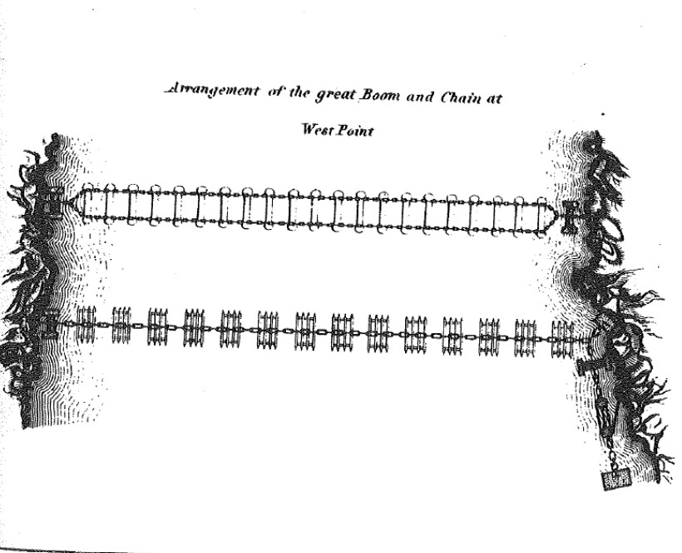
After carefully reading the paragraph and viewing the drawing above, answer the following questions:
- According to the second paragraph, how did the Great Chain help keep ships from sailing up the Hudson River?

- Name two resources that were used to construct the Great Chain.

Document 3:
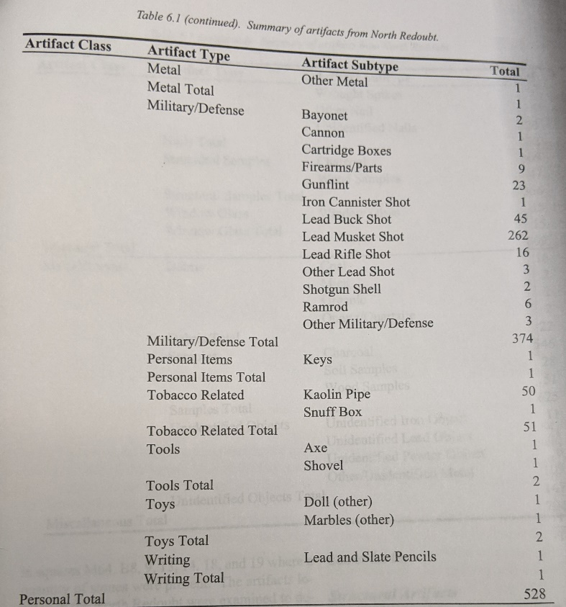
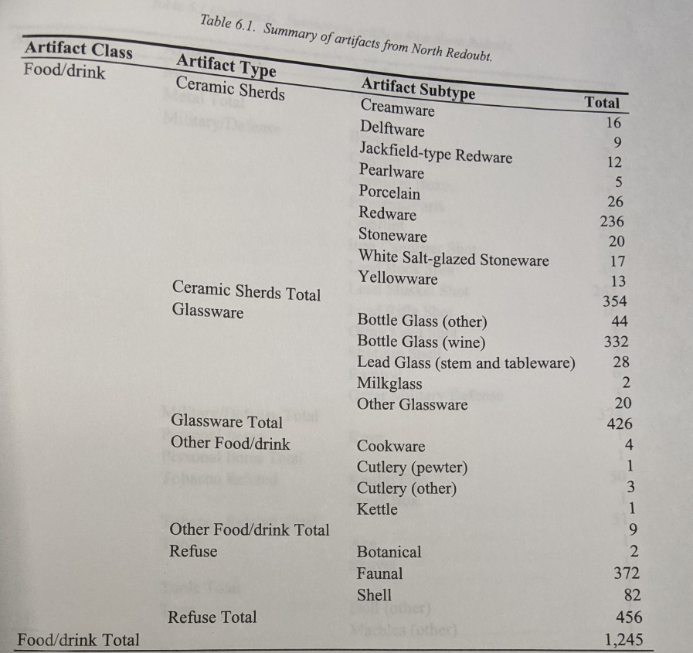

List of artifacts found at the North Redoubt in Garrison, NY

After carefully reading the tables above, answer the following questions:
- Based on what you have learned about soldiers and redoubts, why do you think archeologists found cooking items at the North Redoubt site?

- Think about what a redoubt is made out of, why might soldiers need axes and shovels?

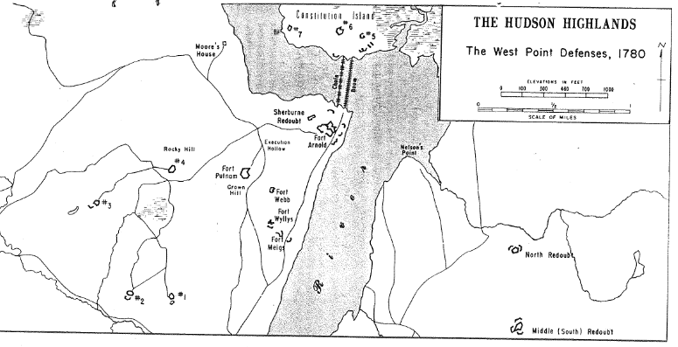
Document 4:

Map of West Point Defenses, including redoubts, the Great Chain, and Forts (1780). (Numbers 1 – 7 on the map are redoubts)

Look closely at the map above and then answer the following question:
- Based on everything you have learned about the Hudson Highlands, explain how the defenses shown on the map helped the Americans Army during the Revolutionary war. Be sure to mention the Great Chain, redoubts, and New York geography in your answer.

